
IDEC Lab Report

Course Title Advanced Language Programming（C）
Topic Lab 1 – Introduction to C language
Name Guo Huangchudi
Registration No. 20221815
Grade 2022
Major Electronic Commerce
Date of Completion 2024.09.09
实验一：编程环境的熟悉
- Purpose
1. Familiarize with Dev C++
2. Familiarize with compiling and uploading programs
3. Familiarize with the basic structure of programs
- Laboratory Equipment
PC with Dev-C++

- Experiments
- Display text on the screen.
Description: Write a program to achieve the function: Display two phrases on the screen "Programming is fun." And "programming in C is even more fun!" Each line displays one sentence.（p.19）

- Inverted triangle pattern.
Description: Output inverted triangle pattern: The following inverted triangle pattern is displayed on the screen. Please try writing the corresponding program.
********
******
***
*

- Results
- Display text on the screen.
Source code:
#include<stdio.h>
int main(void)
{
printf("Programming is fun. \n");
printf("And programming in C is even more fun!\n" );

return 0;
}
Testing：
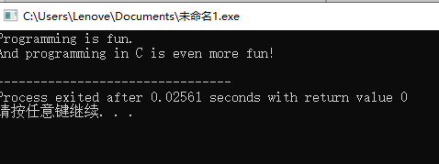
- Inverted triangle pattern.
Source code:
#include<stdio.h>
int main(void)
{
printf("*******\n");
printf(" *****\n");
printf(" ***\n");
printf(" *\n");
return 0;
}
Testing：
